

**By**

**Sunil Raj Thota**

**Date: 06/23/2021**

**Title: Individual Project Proposal**

**ALY 6080 – Integrated Experiential Learning**

**Prof. Atherley, Valerie**

**Introduction:**

Asthma has become one of the world's most prevalent infectious conditions, and it is characterized by fast deterioration. Allergy asthma is the most common type of respiratory problems. Sometimes in patients, infections that cause sneezing fits and eye irritation can also cause an asthma attack. Keva Health Inc is a digital platform that offers tailored health care to everyone. The Experiential Network (XN) Project was sponsored by this company in collaboration with Northeastern University. The main goal is to help patients who are looking for new and inventive ways to manage and offer care for a variety of respiratory ailments.

By examining clinical consumption and providing necessary solutions, these capabilities enable enterprise strategists in establishing and settling on Medicare beneficiaries. I'd would really like to explore very few aspects about information, including its format, value, and also how healthcare organizations like Keva Health be using it. The technology that gathers data from the smart device, ERP, or web client, and even the frequency with which it is utilized, are all taken into account. To prevent being impacted by privacy violations, Keva Health, for instance, must be dedicated to its customers and set strong policies and procedures.

**Statement of Purpose:**

Businesses who wish to take advantage of large datasets should reconsider its methodological approach out of a practical perspective. Another very critical problem to discuss while dealing with huge amounts of data is security. There is a waste of storage and traffic. It hasn't been published. Since, for instance, is peruse, we also do not have total power. Various communities seek to make sense of various monthly figures, as well as the same information is constantly easily misinterpreted by several groups. This is certainly salient of polling data, and that also applies to a wide range of all other metrics.

Seamless data gathering is essential for proper analysis instead of regular information gathering, which necessitates significant impact on corporate policy as well as significant cash flows. Stats, like anything else, could be viewed in many different of perspectives. So, lets provide a better understanding of Keva Health and provide necessary actions that needs to be done by them to increase their business and serve more people who are suffering from the Asthmatic problems.

**Goals & Scope of Project:**

Persons with severe respiratory disorders tend to have bad outcomes regardless the implementation of novel treatments. Develop insights understanding of the available information to make a stunning representation of pollution levels and the opportunity to examine its effect on Hospital readmissions related to Asthmatic. Offer suggestions depending also on patterns you've created. I'm publishing this with the help of the sources I've collected and listed below. Keva Health Inc, although we all understand, is a health-care technology that supports its very own actual diagnostic technology to provide individualized medical services for everybody.

**Background Research & Literature:**

I have done lots of research and reviewed lots of papers, websites, blogs, and articles regarding similar healthcare companies who are working on the respiratory issues like Keva Health. I'm preparing this done in order to evaluate on the references I've gathered and provided here. Though we all know, Keva Health Inc is a medical organization that specializes on its meaningful remote monitoring, that enables all of us to receive personalized medical care. It is one of the few companies who have been aggressively dealing with these projects and developing its own monitoring system and provided a platform for the patients to communicate directly with the doctor.

**Design & Data Collection Methods:**

Information searches must be specifically known whilst considering the sector you're into it and the competitors you're aiming to outperform. It allows the viewers to find new things they like. Insights may assist firms in determining what they're on about correctly and incorrectly. Inadequate recognition can result in inaccurate perception, that could wreak havoc on company performance, actual quality, and cause problems. Instead of speculating, companies can get a close result by analyzing. This also shows how this performs and what it doesn't in either a range of diverse domains, such as digital marketing, online advertising, and lead generation. So, designing and collecting data should be governed well and I have fetched the data from the suggested websites like EPA and CDC.

**Implementation Methodology, Analysis, & Strategies:**

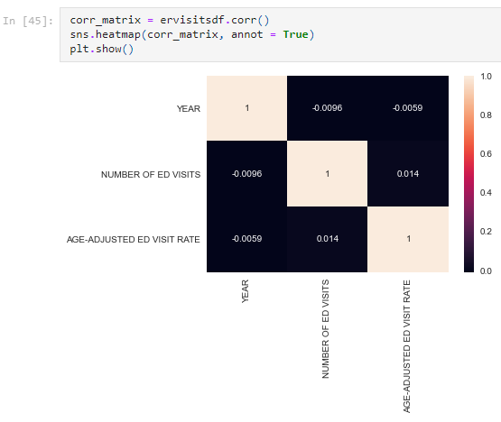

The above correlation plot is analyzed using the ER Visits Dataset.

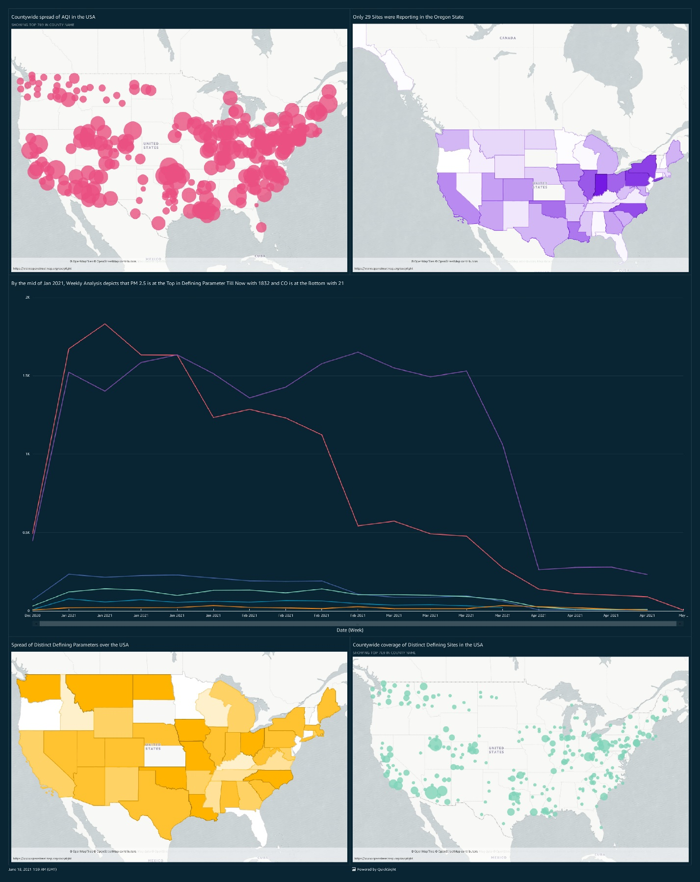The above plots and dashboard represents the county wide analysis of various pollutants over the USA.

To assess the associations and connections among data, the linear regression analysis tool has been used. It shows how well the reliant variable's typical value fluctuates. In a summary, data - driven study is concerned with assessing qualitative and quantitative information in forecasting events, encompassing different possibilities and hazard identification.

Participants can obtain health information, receive comments specific to recognized problem areas, and assess and seek input upon on development of their character habits using the Keva Health technology platform. They've established a simulated functioning criterion to offer physicians with both the information they need to help asthmatics lead better lives. Keva Health, a medical tech firm, is notable for developing virtual care operations and laying the groundwork for telemedicine therapy.

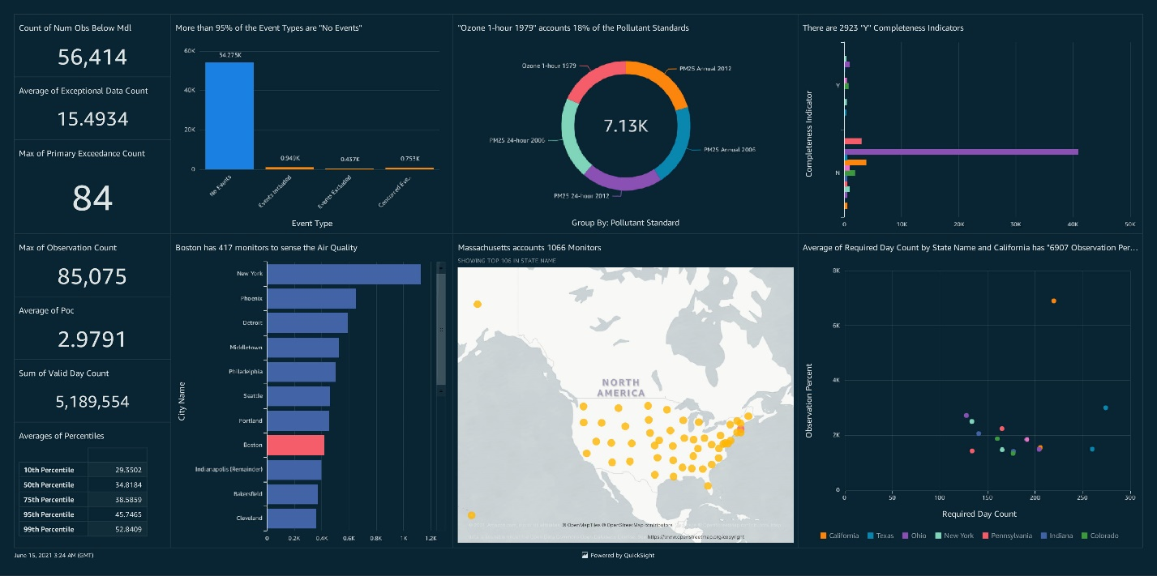

The above dashboard represents the overall analysis of the Annual Conc. Of the monitors over the USA.

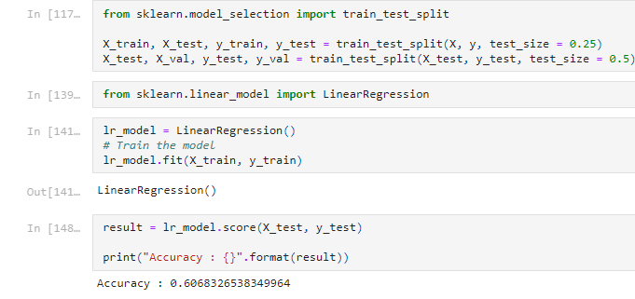

I have done some analysis and experimented in producing and developing a machine learning models like linear regression, decision tree, and random forest algorithms. Linear Regression for ER Visits dataset was around 60%.

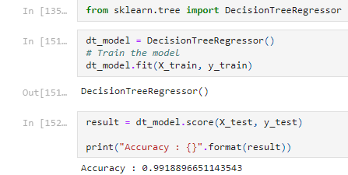

The above metrics show the Decision Tree Model with 99% and the below plot shows the Random Forest with 98%

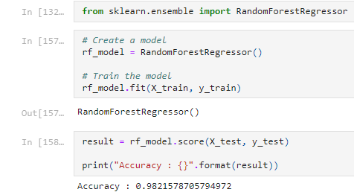

I'll look into how the Pollution Level has evolved over the years and relate it to the number of hospitalizations. I'll employ descriptive, interpretive, forecast, and proactive analysis for all of this assignment. It entails using current information and calculations like average, extent, lowest, recurrence, medium, mode, percent, and highest to define, summarize, and find trends. For the client, I'll explain the corporation's business plans and review the data using AWS Quick Sight capabilities in a visual format. Members gain personalized input and guidance based on specific concerns and max flow metrics, as well as alerts by their hospital about medical training. To prevent being impacted by cybersecurity incidents, Keva Health, for illustration, must be dedicated to its customers and set strong security policies. This method is beneficial in regards of their company for individuals who are about to get treated using their legitimate methodology.

**Conclusion:**

In the next, I'll investigate and display the data using the Visualization Analyzer. Search for relevant information on hospitalized patients and get the air now statistics. Analyze and create a realistic description to assess the impact of air quality on healthy individuals. Tips for how to use this knowledge to assist lung patients. We'll conduct experimentation in this manner. We can look back in time with EDA. As we delve deeper into the details, we receive greater understanding. Examine the effect of pollution levels on patients with asthma by making an assessment and creating a visual representation. Guidelines for using this information to help lung sufferers

**References:**

[1] Madanian S, Parry DT, Airehrour D, et almHealth and big-data integration: promises for healthcare system in IndiaBMJ Health & Care Informatics 2019;26:e100071. doi: 10.1136/bmjhci-2019-100071